2016 AP Macro Exam

MC Questions
- Question 1 is based on the diagram below, which shows the production possibilities curve for an economy that produces only two goods: X and Y.
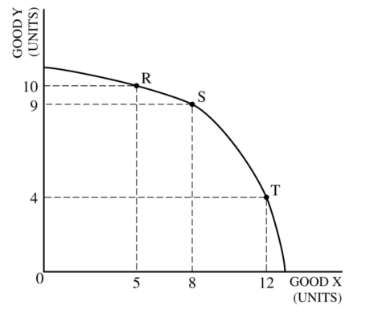
The opportunity cost of moving production from point R to point T is
- one unit of Good Y
- five units of Good Y
- six units of Good Y
- three units of Good X
- seven units of Good X
- If a country’s production possibilities curve is shifting outward, which of the following must be true.
- There is cyclical unemployment
- The price level is increasing
- the aggregate demand curve is shifting to the right
- The long run Phillips curve is shifting to the right
- The long run aggregate supply curve is shifting to the right
- In a closed economy with lump sum taxes, if the marginal propensity to consume increased from 0.5 to 0.75 the simple spending multiplier and marginal propensity to save (MPS) would change in which of the following ways.
Multiplier MPS
- increase increase
- increase decrease
- no change decrease
- decrease increase
- decrease decrease
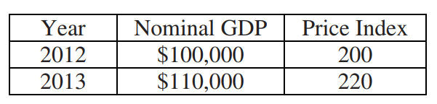
- The table shows the nominal gross domestic product (GDP) and the price index for an economy during the period 2012 and 2013. Which of the following would have occurred from 2012 to 2013.
- Real GDP decreased by 20%
- Real GDP increased by 20%
- Real GDP increased by 10%
- Real GDP did not change
- An autonomous decrease of 10 million in investment spending will most likely result in
- a decrease of exactly 10 million in gross domestic product
- a decrease of more than 10 million in gross domestic product
- an increase of 10 million in taxes to offset the decrease in investment
- an increase of 10 million in aggregate supply to offset the decrease in investment
- an increase in the cost of loans for investment purposes
- The circular flow model indicates that final goods are produced by
- firms and sold in the factor markets
- firms and sold in the product markets
- firms and sold in the resource markets
- households and sold in the factor markets
- households and sold in the product markets
- Which of the following is most likely to promote long run economic growth?
- An increase in government transfer payments
- An increase in income taxes for middle class households
- An increase in tax credits for business spending on research and development
- An increase in unemployment compensation
- An increase in financial capital outflow
- The table below shows a country’s macroeconomics data in 2013.
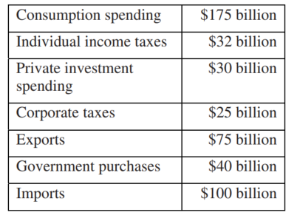
The country’s gross domestic product is
- 220 billion
- 282 billion
- 304 billion
- 309 billion
- 347 billion
- Which of the following is a monetary policy that can be used to counteract a recession?
- Increasing Interest Rates
- Decreasing Interest Rates
- Keeping Interest Rates constant
- Increasing Tax
- Decreasing Government Transfer Payments
- When an economy producing two goods is operating efficiently and at full employment, increasing the production of one good will result in
- an inward shift of the production possibilities curve
- an outward shift of the production possibilities curve
- a decrease in the amount of the other good that can be produced
- an increase in the costs of both goods
- an increase in the amount of resources available
- Brazil and Peru produce both coffee and wheat using labor as the only input. The table below shows the labor hours required to produce a unit of coffee and a unit of wheat in each country.
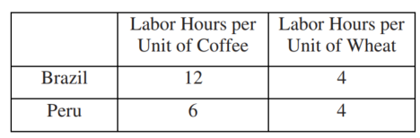
Based on the information in the table above, which of the following is true?
- Peru has a comparative advantage in producing wheat.
- Peru has an absolute advantage in producing wheat.
- Brazil has an absolute advantage in producing wheat.
- Peru has comparative advantage in producing coffee.
- Brazil has a comparative advantage in producing coffee.
- Gross private domestic investment includes which of the following?
- Changes in business inventories
- National defense spending
- New durable goods purchased by households
- Transfer payments
- Depreciation of government goods
- An increase in which of the following is most likely to increase employment and promote long run economic growth?
- Government spending on education
- Transfer payments
- Reserve requirements
- Income tax rates
- Unemployment compensation
- Technological progress promotes long run economic growth primarily by
- increasing the supply of financial capital
- increasing the labor productivity
- decreasing the national savings
- decreasing budget deficit
- decreasing nominal wages
- In an economy the marginal propensity to consume is 0.90, and gross domestic product (GDP) is $100 billion. If gross private domestic investment declines by $2 billion, then GDP will
(A) decrease by a maximum of $1.8 billion
(B) decrease by a maximum of $2 billion
(C) decrease by a maximum of $20 billion
(D) increase by a maximum of $1.8 billion
(E) increase by a maximum of $20 billion
- Melanie quits her job to look for a better one that has opportunity for advancement. Melanie will be classified in which category of unemployment?
(A) Frictional
(B) Hidden
(C) Seasonal
(D) Structural
(E) Cyclical
- Which of the following is a best example of an investment in human capital?
(A) Decreasing the wage rate
(B) Training workers
(C) Hiring new workers
(D) Buying new equipment
(E) Updating technology
- The graph above shows aggregate demand (AD), short-run aggregate supply (SRAS), and long-run aggregate supply curves for an economy. Based on the graph, cost-push inflation is caused by a movement from
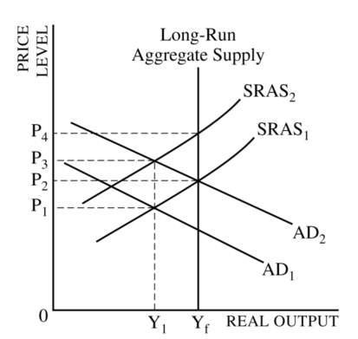
(A) SRAS1 to SRAS2
(B) SRAS2 to SRAS1
(C) AD1 to AD2
(D) AD2 to AD1
(E) Y1 to Yf
- Assume a country’s government has a balanced budget. If the economy goes into a recession, what will happen to the government’s budget in the short run?
(A) It will be in surplus, because the government will increase its spending.
(B) It will be in surplus, because there will be an automatic decrease in unemployment payments.
(C) It will be in deficit, because the government will raise the tax rates.
(D) It will be in deficit, because the price level will decrease.
(E) It will be in deficit, because there will be an automatic decrease in tax receipts.
- Following a decrease in aggregate demand, an increase in unemployment will result if
(A) prices increase and real wages decrease
(B) the aggregate supply curve is vertical
(C) prices and wages quickly adjust to equilibrium levels
(D) short-run aggregate supply also increases
(E) prices and nominal wages are slow to adjusting the short run
- In the long run, a fully anticipated increase in the inflation rate will
(A) increase real national output
(B) increase the nominal interest rate
(C) decrease real national output
(D) decrease the real interest rate
- The graph above shows the demand for and supply of a good. If the market price is P1, then
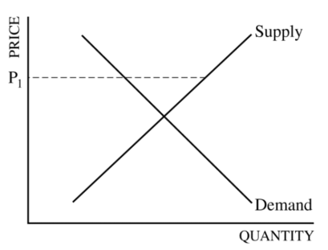
(A) there is a shortage, and the price will rise
(B) there is a shortage, and the price will fall
(C) there is a surplus, and the price will rise
(D) there is a surplus, and the price will fall
(E) demand will decrease and supply will increase
- Assume an economy is in a long-run equilibrium. Following a decrease in aggregate demand, which of the following is true in the short run?
(A) The unemployment rate is equal to the natural rate of unemployment, and the rate of inflation is rising.
(B) The unemployment rate is greater than the natural rate of unemployment, and the rate of inflation is rising.
(C) The unemployment rate is greater than the natural rate of unemployment, and the rate of inflation is declining.
(D) The unemployment rate is lower than the natural rate of unemployment, and the rate of inflation is declining.
(E) The unemployment rate is lower than the natural rate of unemployment, and the unemployment rate is rising.
- An increase in consumer confidence will result in which of the following in the short run?
(A) A rightward shift of the long-run aggregate supply curve
(B) A rightward shift of the short-run aggregate supply curve
(C) A leftward shift of the short-run aggregate supply curve
(D) A rightward shift of the aggregate demand curve
(E) A leftward shift of the aggregate demand curve
- Which of the following mixes of fiscal and monetary policy would reduce inflation?
Fiscal Policy Monetary Policy
(A) Decrease spending Buy bonds
(B) Decrease taxes Buy bonds
(C) Increase taxes Sell bonds
(D) Increase spending Buy bonds
(E) Increase spending Sell bonds
- The natural rate of unemployment is the unemployment rate when
(A) all workers seeking employment have taken jobs
(B) all the unemployed are only structurally unemployed
(C) there is no frictional unemployment
(D) there is no cyclical unemployment
(E) there are no new unemployed individuals
- In 2007, the nominal gross domestic product(GDP) was $50 billion and the GDP deflator was 200. Thus real GDP was
(A) $150 billion
(B) $100 billion
(C) $50 billion
(D) $25 billion
(E) $4 billion
- Nations A and B produce only chairs and bicycles. If each laborer in Nation A can produce twice as many chairs as each laborer in Nation B, then which of the following is necessarily true?
(A) Nation A has a comparative advantage in chairs.
(B) Nation A has a comparative advantage in bicycles.
(C) Nation A has an absolute advantage in chairs.
(D) Nation B has an absolute advantage in bicycles.
(E) Nation A should specialize in producing chairs.
- Which of the following is true about the expected real interest rate?
(A) It is equal to the nominal interest rate plus the expected inflation rate.
(B) It is equal to the ratio of the nominal interest rate to the inflation rate.
(C) It increases as the price level increases.
(D) It is always positive.
(E) It is negative if the expected inflation rate exceeds the nominal interest rate
- The aggregate supply and aggregate demand graph above shows the current macroeconomic equilibrium of an economy. How will the price level and real output change if there is a sharp increase in productivity and a simultaneous increase in government purchases?
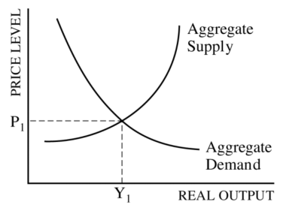
Price Level Real Output
(A) Increase Increase
(B) Increase Decrease
(C) Indeterminate Increase
(D) Indeterminate Decrease
(E) Indeterminate Indeterminate
- In the short run, cost-push inflation can be caused by
(A) printing too much money
(B) increased government spending
(C) negative supply shocks
(D) decreased tariffs
(E) decreased taxes
- Which of the following necessarily occurs during an economic recession?
(A) Cost-push inflation decreases.
(B) Real gross domestic product decreases.
(C) Cyclical unemployment decreases.
(D) Demand-pull inflation increases.
(E) Nominal wages increase.
- Which of the following will cause an increase in real output in the short run?
(A) A decrease in productivity
(B) A decrease in wages
(C) A decrease in government expenditure
(D) An increase in reserve requirements
(E) An increase in the discount rate
- A lender will realize unexpected benefit when the
(A) actual inflation rate is higher than the anticipated inflation rate
(B) actual inflation rate is lower than the anticipated inflation rate
(C) rate of interest is greater than the actual rate of inflation
(D) rate of interest is less than the actual rate of inflation
(E) rate of interest equals the actual rate of inflation

Free Response
- The economy of Zarland is operating below the full-employment level of output with a balanced budget.
(a) Draw a correctly labeled graph of short-run aggregate supply, long-run aggregate supply, and aggregate demand, and show each of the following.
(i) The country’s current equilibrium output and price level, labeled Y1 and PL1, respectively
(ii) The full-employment output, labeled Yf

(b) If Zarland increases government expenditures and taxes by equal amounts, can aggregate demand increase?
Explain.

(c) If Zarland decides to pursue an expansionary monetary policy, what change to interest rates should the government make?
Explain.

- Assume that the current unemployment rate in Country A is lower than the natural rate of unemployment.
(b) Identify a specific fiscal policy action that would bring the economy to full employment.

(d) Now assume instead that there is no fiscal policy action. Will the SRAS shift to the right,
shift to the left, or remain the same over time? Explain.

Answers
